**Assignment 1**

* **First, I downloaded the codebase from the assignment and extracted it to the folder "d" under "DevOps Training" and "Assignment 1". Then, I initialised Git using the command "git init" to initialise a local repository. Next, I added all the files to the local repository using the command "git add.". After that, I created a new branch using the command "git checkout -b branchname" and added a sample file and a test file.**

* **Once I finished working on the branch, I checked out the "master" branch using the command "git checkout master". Then, I merged the branch I created earlier into the "master" branch using the command "git merge branchname".**

* **To create a remote repository on GitHub, I used the command "git remote add origin git_url," where "git_url" is the URL of the GitHub repository. Finally, I pushed the "master" branch to the remote repository using the command "git push origin master".**

**Screenshot of commands**

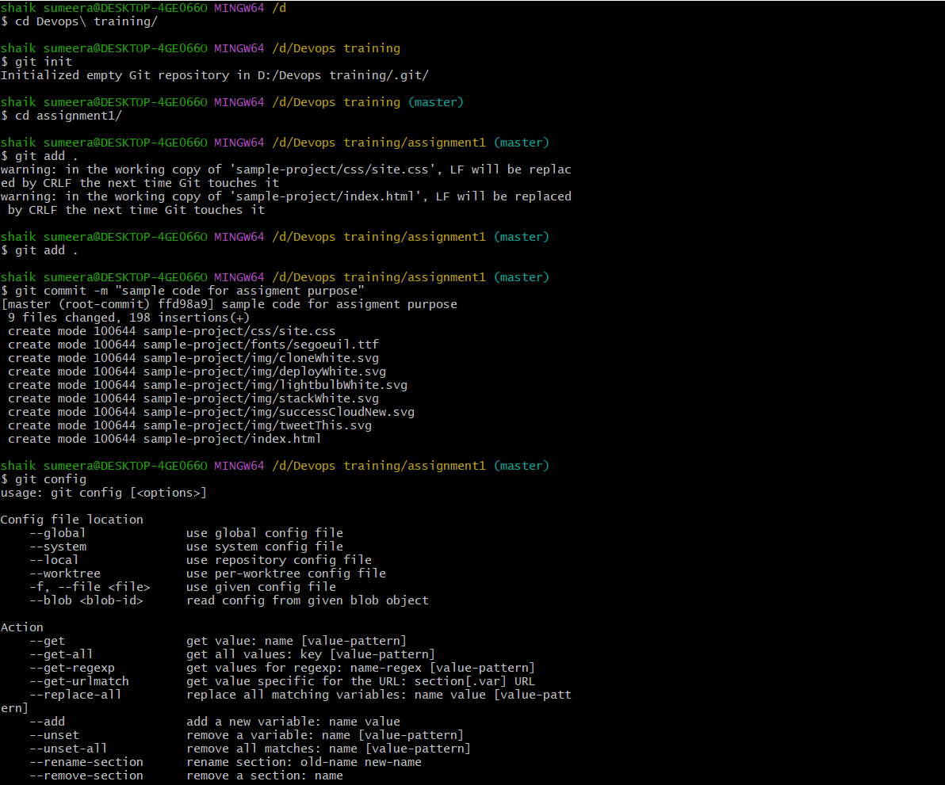

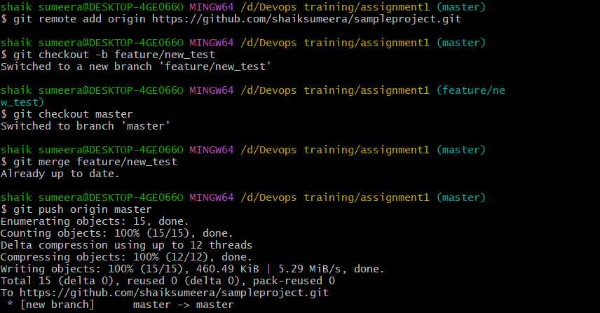

**Folder**

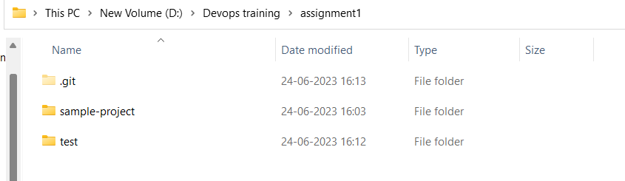

**Git url - https://github.com/shaiksumeera/sampleproject.git**